Requirement # 1: Need specific fields here
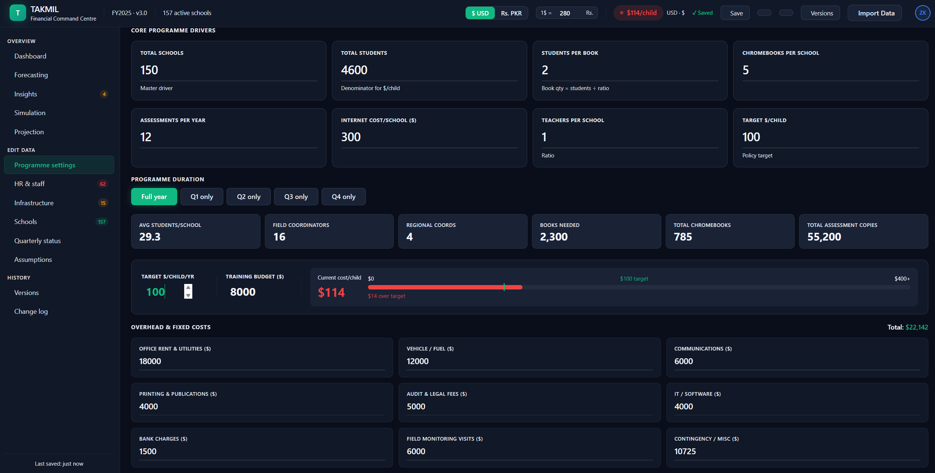
For Overheads and Fixed Costs:
- Need Following Options:
  - Office Rent-Lahore
  - Office Rent- Islamabad
  - Audit and Legal Fees
  - Petty Cash
  - Shipment Costs
  - Repair and Maintenance Cost (Not sure where to fit technology repair or should we add for each school?)
  - Miscellaneous/Contingency
  - New Projects:
    - AI Project
    - Sustainability
    - Curriculum Developments
  - Software: (Note: Here we need to specify if the software is for Pakistan or North America & if the Software is for Data/LMS Vertical)
    - PayPeople
    - Azure
    - Microsoft Power BI
    - Bloomerang
    - Zoom
- For each of these costs, I need to specify if this cost is for Pakistan vs North America

Requirement # 2: New Departments Options
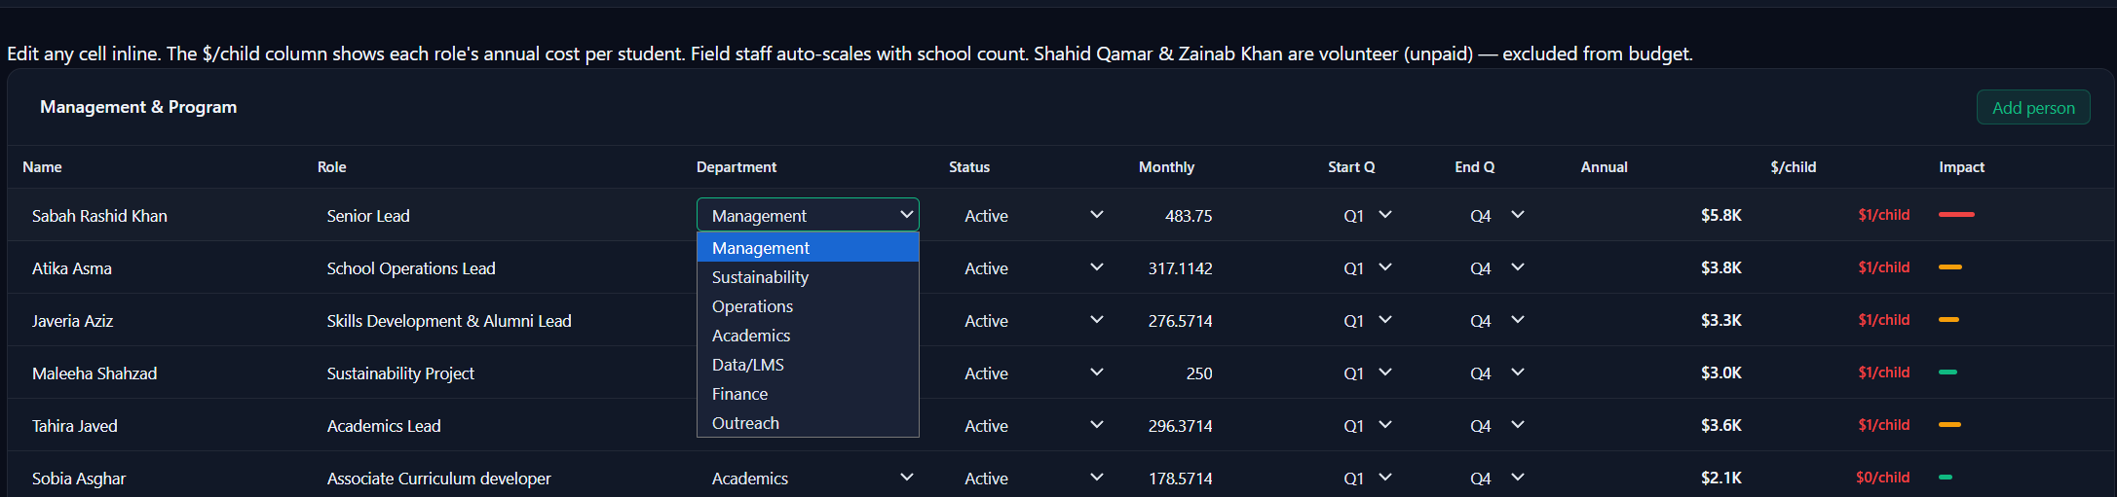
Current:
- Management
- Sustainability
- Operations
- Academics
- LMS/Data (Should we split Data vs LMS?)
- Finance Finance & HR
- Outreach
- North America (To Add)
- Marketing (To Add)
Requirement # 3: Cost/Child Projection
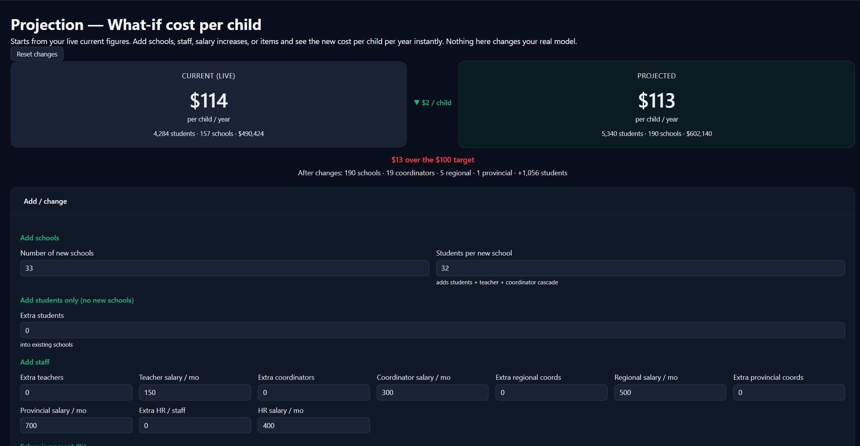
Here we need some categories:
- Current Cost with Data and LMS
- Current Cost without Data and LMS
- Current Cost without North America Cost
- Current Cost without Data and LMS and North America Cost
- Projected one should remain as it is.

Requirement # 4: Data Import For Schools
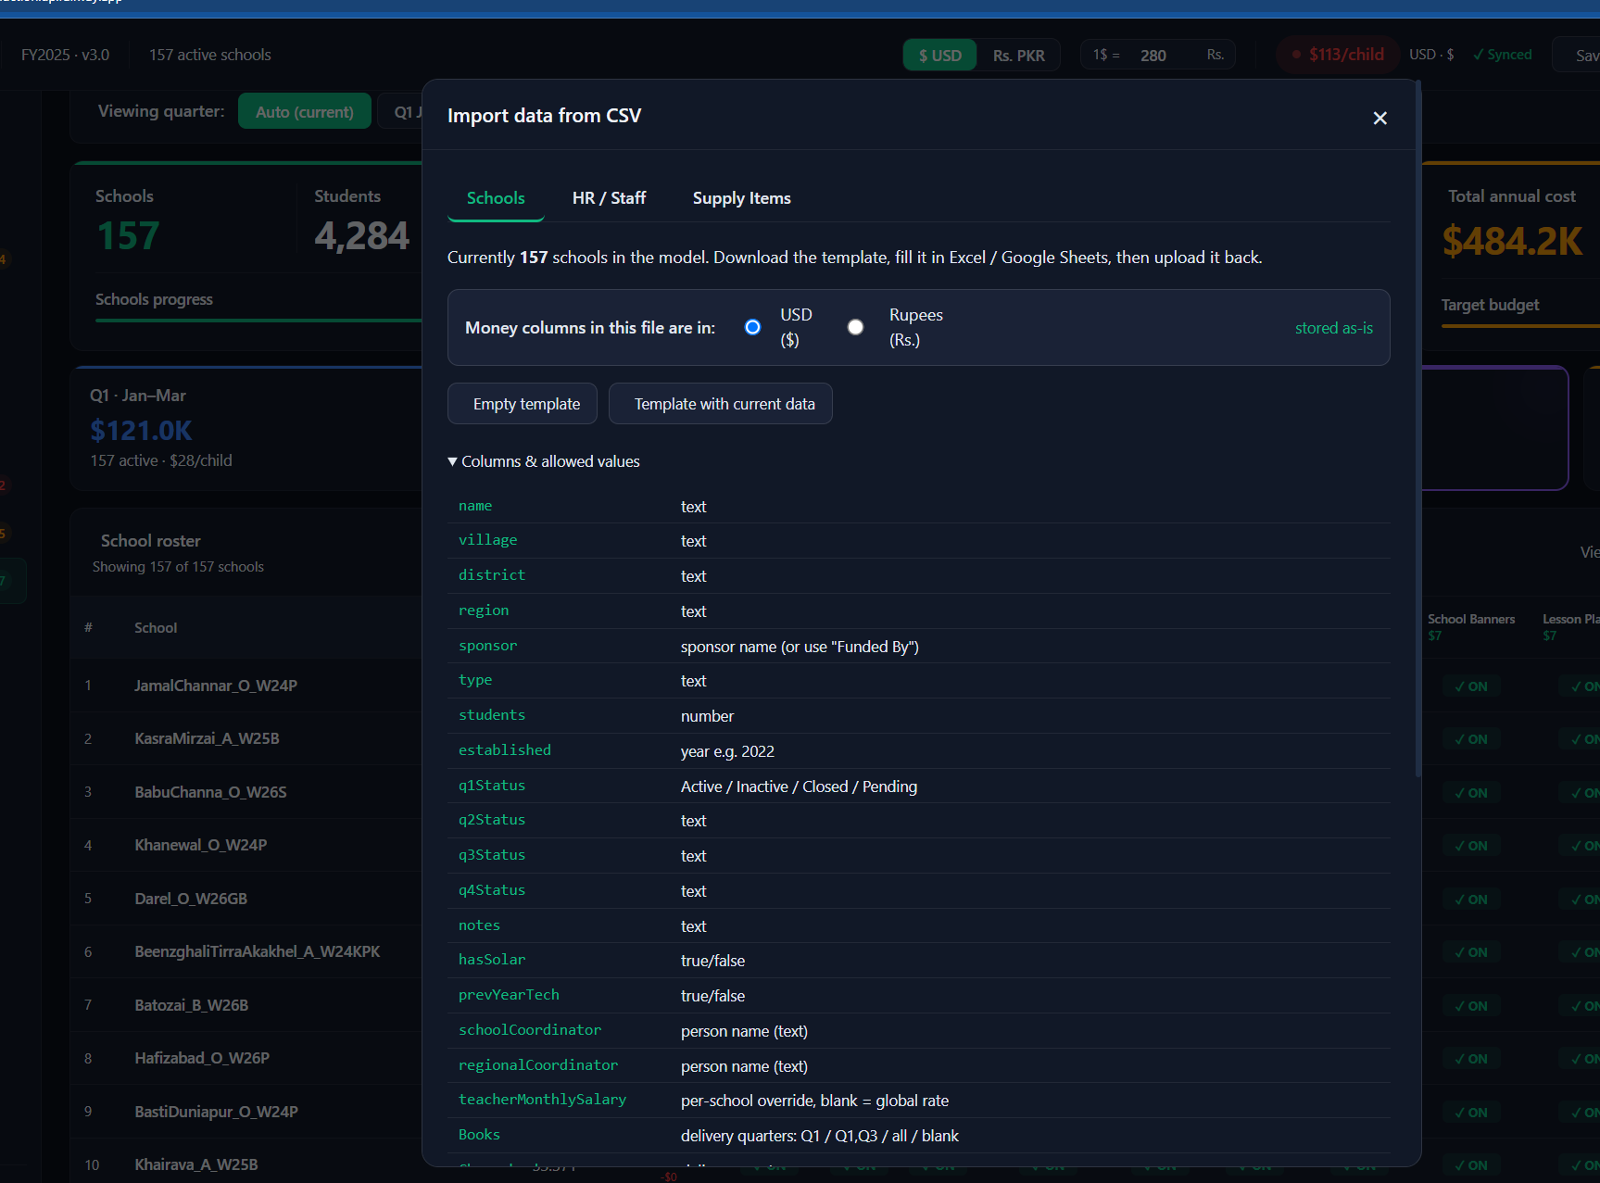
I need exact data entry options.
I tried Quarter and True/False in Import Sheet but nothing changed on Infrastructure settings. It seems the system is assuming all schools need these supplies and only need to specify quarters.

